C29PE Tutorial 2 - Questions

1. The formula for price elasticity of demand is as follows:
Proportionate (or percentage) change in quantity demanded
Proportionate (or percentage) change in price

This can be summarised as: ΔQ_{d} / mid Q_{d} ÷ ΔP / mid P

The following table shows the quantity of a product demanded at two different prices:

P | Q_{d}
16  14 | 25  35

(a) Calculate the proportionate change in quantity demanded when price falls from £16 to £14.
(Use the first part of the formula, i.e. ΔQ_{d} / mid Q_{d} , to do your calculation.)

(b) Calculate the proportionate change in price when price falls from £16 to £14.
(Use the second part of the formula, i.e. ΔP / mid P, to do your calculation.)

(c) What is the price elasticity of demand between £16 and £14?

2. The following diagram shows two demand curves that cross at a price of P₀.
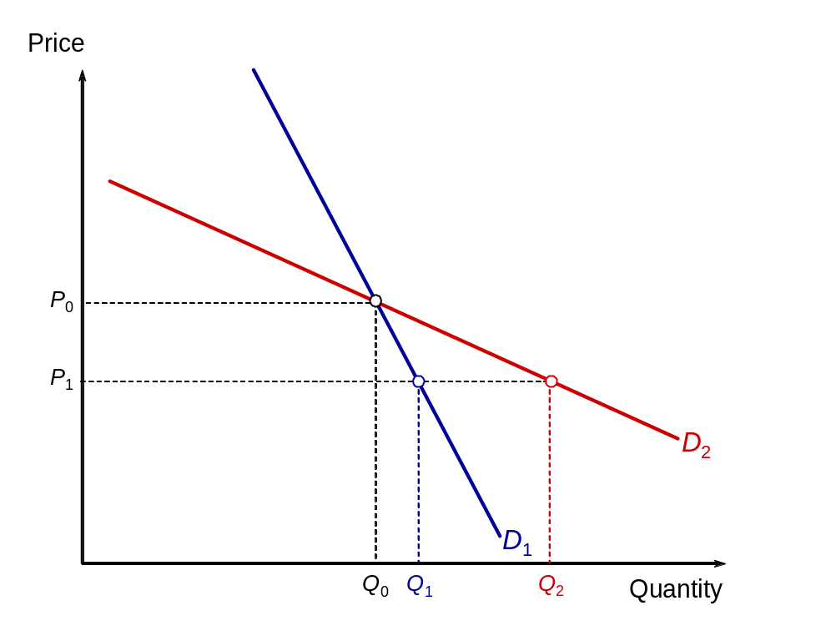
Which of the following statements are true?

- Curve D₁ is inelastic and curve D₂ elastic

(b) Demand is more elastic between P₀ and P₁ along curve D₂ than along curve D₁

(c) For any given change in price there will be a larger proportionate change in quantity along curve D₁ than along curve D₂

3. People generally buy goods and services because they expect to gain satisfaction from them. We call this satisfaction utility. An important distinction we make is between total and marginal utility.

- Define total utility (TU)

- And marginal utility (MU)
.

- The following diagram shows the marginal utility (MU) that a consumer gets from consuming different quantities of a product. Assume that the current market price of the product is P.

- 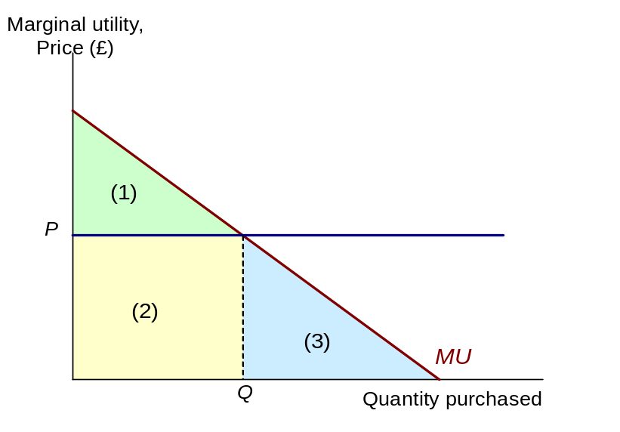Why is the optimum consumption point at Q?

- What area(s) represent(s) total utility at Q?
(iii) What area(s) represent(s) the consumer’s total expenditure at Q?
(iv) What area(s) represent(s) the consumer’s total consumer surplus at Q?

Sample exam questions

4. Discuss briefly whether you consider that market demand or market supply for petrol will be more price elastic. Draw a diagram in which market demand is a downward sloping line, and market supply is an upward sloping line. Choose the slopes to reflect the assumptions about the price elasticities of demand and supply in 1e). Mark the market equilibrium as point A on your diagram. At point A, assume that the price of petrol is $1.20 per litre.

- The government now imposes a tax on petrol of $0.60 per litre. Indicate how we can illustrate the effect of the tax (i) on the market supply curve, (ii) on the market equilibrium; and (iii) on the government’s revenues. Mark the market equilibrium as point B.
- Mark point C, on the market supply curve before the tax was imposed, directly below point B. What can we tell from point C?
- The sellers of petrol collect the tax for the government. Why would it be wrong to say that the sellers pay the tax.
- Define the tax incidence which falls on sellers of petrol, and the incidence which falls on buyers of petrol. Using your diagram, which bears the larger proportion of the incidence.
- Relate the answer for part b) to your argument about the price elasticities of supply and demand in 1e). Explain why a relatively inelastic demand, means that governments can generate high tax revenues.

- The market for white coffee is highly competitive in Malaysia, as it is a popular coffee beverage. A market researcher estimated that the demand per day for white coffee in Putrajaya is given by the equation Q = 200/P. The supply of white coffee is perfectly elastic at price of $10 from 0 to 80 cups of coffee per day. When market supply hits 80 cups per day, supply becomes perfectly inelastic.
- Draw a diagram depicting the market for white coffee. Show the equilibrium price and quantities in the diagram. Draw the areas which represent the consumers’ surplus and the producers’ surplus.
- Suppose that the demand for white coffee increases due to advertisements by social media influencers. The new demand curve is now represented by Q = 1600/P. Draw the diagram again and indicate the areas representing consumers’ surplus and producers’ surplus. Comparing with the initial equilibrium, what happens to the new equilibrium price and quantity?
- Explain the effects on prices and quantities if demand continues increasing.

Supplementary questions (will not be discussed in class)

- In the mid-1990s, the government in the UK announced that for every 10 per cent rise in the price of cigarettes, the demand is likely to fall by 6 per cent. If this information is correct, what is the value of the price elasticity of demand for cigarettes?

- In each of the following pairs, tick which of the two items is likely to have the more elastic demand. Give reasons for your answer.

(a) Petrol (all brands) Esso petrol
There is no close substitute for petrol. If the price of petrol went up, the quantity demanded would fall only slightly, as people would still need fuel for their cars. If the price of Esso petrol went up, however (assuming that the prices of other brands had not changed), people could easily switch to other brands.

(b) Holidays abroad Bread

People could easily substitute cheaper holidays, at home or abroad, if the price of foreign holidays rose. The substitutes for bread are less close, and people spend a relatively small proportion of their income on bread. A rise in the price of bread, therefore, is likely to result in only a small fall in the quantity demanded.

(c) Salt Clothing

People spend such a small proportion of their income on salt that they could easily afford to pay a higher price – and would probably not even be aware that the price had risen. Do you know the price of a drum of salt?

- Fill in the rest of the following table:
(For the final column use the formula: ΔQ_{d} / mid Q_{d} ÷ ΔP / mid P)

Quantity demanded (000s) | Price  (£) | Total consumer expenditure | Elastic or inelastic demand | Price elasticity of demand
7  9  11  13 | 13  11  9  7 | 91  99  99  91

- The figure opposite shows the total utility that Raj, a first-year degree student, would receive from different levels of annual income.

Raj’s total utility from his income
Assume at the moment that his annual income (from an allowance from his parents and some part-time work in a burger bar) is £4000. Spending this rationally gives him a total utility of 500 ‘utils’.
TU
Assume that he is offered the chance to gamble the whole £4000 on the single toss of a coin. If he wins then he doubles his money and has an income of £8000. If he loses then then he has to pay £4000 and so has no income left.

(a) If he takes the gamble, what will be his utility this year if he wins?
(b) If he takes the gamble, what will be his utility this year if he loses?

(c) What would be his expected utility from the gamble?

(d) Why is it likely that he will not take the gamble, and thus be risk averse?

Assume now that Raj does not take the gamble but is still worried because there is a 16 per chance that his £4000 will be stolen. An insurance company offers him a full insurance policy against this loss for a premium of £800.
- What is the expected value of taking the gamble (i.e. of not taking out the insurance)?

- What is his expected utility from taking the gamble (i.e. of not taking out the insurance)?

- What is his expected utility if he purchases the insurance (i.e. pays the £800 premium)?

- Would he buy the insurance policy for a premium of £800?

- Would be buy the insurance policy for a premium of £750?

- Assume the insurance has many customers in exactly the same position as Raj i.e. facing a 16 per cent change that their income of £4000 will be stolen. How much will it pay out on average in claims per customer? Can it make a profit if it charges a premium of £750?

- Assume now that when customers like Raj take out the insurance policy they takes less care with their money and the chances of it being stolen increase from 16 per cent to 25 per cent. Explain any problems this might cause the insurance company.

